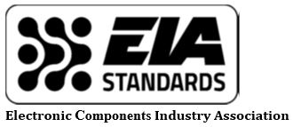
2019 Engineering Fall Summit
October 9-10, 2019
The Westin Poinsett, Greenville, SC

Preliminary Program
Date | Interest Category | Committee Meeting or Event
Tues., October 8
4:00 – 5:00 pm |  | Working Group activities (as needed)  New attendee orientation
Wed., October 9

9:00am - 10:15am | All Participants | S-1 Committee Users' Group/General Session
 |  | P-2.2 Paper, Film, Mica & Wet Electrolytic Capacitors
 |  | P-3 Inductive Components
10:15am -10:30am |  | Break
10:30am -11:00am |  | Procedural training & updates EP-20 Revision
11:00am - Noon | Tantalum Capacitors | P-2.5 Solid Electrolytic Capacitors
 | Ceramic Capacitors | P-2.1. Ceramic Capacitors
12:00 - 1:00pm | All Participants | Lunch
1:00pm – 1:30pm | All Participants | iNEMI Roadmap workshop
1:30pm - 2:00pm | Resistors and IPDs | P-1 Resistive Devices and P-10 Integrated Passive Devices
2:00pm - 4:00pm | Soldering and Lead-Free | STC-Soldering Technology Committee
4:00pm - 4:30pm | All Chairs & Interested | EIA Standards Council (All Chair's Meeting)
5:00pm – 6:00pm | All | Reception
Thur., October 10

8:00am - Noon | Automated Component Handling, Tape & Reeled Product and Carrier Trays | ACH Automated Component Handling Committee

